NPDN 2025 Annual Report

Overview
NPDN is a network of plant health diagnostic professionals and laboratories working together to support plant health and biosecurity in U.S. agricultural and natural ecosystems. NPDN facilitates nationwide access to diagnostic capacity, communication, coordination, and pest and disease diagnostic information.

A network of distributed diagnostic capacity
NPDN has established a nation-wide presence representing 125 laboratories in land grant universities (LGU), state departments of agriculture (SDA), federal agencies, and industry. NPDN members are in all 50 states and 4 U.S. territories.
206 NPDN members, including 178 plant diagnostic professionals
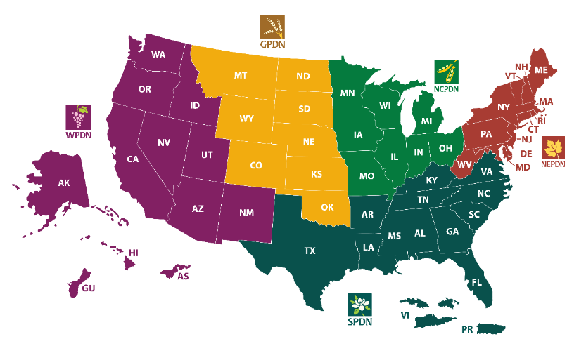
To effectively coordinate the work of dozens of institutions and members across the U.S., the NPDN is divided into five regions, each organized around a Regional Center as follows:
- Northeast Plant Diagnostic Network (NEPDN), University of Maine
- Southern Plant Diagnostic Network (SPDN), University of Florida
- North Central Plant Diagnostic Network (NCPDN), Michigan State University
- Great Plains Diagnostic Network (GPDN), Kansas State University
- Western Plant Diagnostic Network (WPDN), University of California, Davis
Each regional center has been selected in a competitive grant process and oversees coordinating the communication and support of laboratories for all states in their region. Regional centers also work together to coordinate and implement all network programs and initiatives at the national level.

NPDN 2025 Accomplishments
This report lists the accomplishments of 71 labs from 49 states and 2 territories that answered the 2025 NPDN Lab Capacity and Impact Evaluation. This included 64 NPDN-funded labs and 7 additional non-funded NPDN labs.

Diagnostic capacity
NPDN facilitates access to diagnostic capacity and pest and disease diagnostic information nationwide.

Diagnostic capability
NPDN members are mostly plant pathology and entomology labs, but they also provide diagnostic services in other fields of plant health listed below.
 | Pathology | Entomology | Nematology | Nutrient Analysis | Seed Testing | Plant/weed Identification
Number of NPDN Lab Providers | 67 | 56 | 44 | 11 | 14 | 41
Labs are equipped to conduct diagnostics using traditional techniques including visual diagnostics, incubation, isolation, and microscopy. In addition, labs have capability for basic and advanced molecular diagnostic techniques and other specialized tests listed below.
Diagnostic Method Category | Number of NPDN lab providers
Conventional PCR | 57
Real-time PCR | 50
ELISA | 56
Basic DNA sequencing | 45
Next-generation sequencing | 9
Isothermal amplification | 39
Resistance tests | 20
Bioassay | 38
Labs make extensive use of the network to access additional diagnostic expertise.
59 NPDN labs (83%) can receive referral samples from other labs.

Diagnostic capacity
NPDN’s extensive network of labs processed 184,994 samples in 2025. In the event of an emergency this diagnostic capacity can be tapped to provide surge support.
In addition, some labs are equipped to provide specific support for organisms of concern.
Number of NPDN labs with surge support capability for organisms of concern:
Regulated organism | Full capability | Some capability
Phythophtora ramorum ELISA | 27 | 16
Plum Pox Virus ELISA | 22 | 14
HLB qPCR | 11 | 12
Pospiviroids | 9 | 6
ToBRFV | 26 | 22
Other APHIS-listed | 16 | 10
Other (State listed) | 16 | 11

First detections
Plant biosecurity requires early detection and quick communication of deliberate or accidental introductions of pests and diseases nationwide.
In 2025, labs reported 312 detections of pests or diseases found for the first time in a state or in the U.S. Labs are trained to report new detections of pests or diseases to state and federal regulatory partners, who can take informed action to prevent their spread.
A wide footprint is necessary to provide successful surveillance of new pests and diseases. In 2025 labs received samples from 73% of the U.S. counties.

National Data Repository
The NPDN maintains the most comprehensive database of pest and disease information in the U.S. The NPDN National Data Repository (NDR), provides the plant diagnostic community with information on whether an organism is present, new, emerging, re-emerging, or increasing in any given area. NPDN NDR continuously collect diagnostic data from NPDN diagnostic laboratories to ensure quality and up-to-date information.
In 2025, the labs added 131,636 new pest and disease records to the NDR.

Quality in Diagnostics:
NPDN supports high-quality in diagnostics through constant improvement and quality assurance programs.

Laboratory Quality Accreditation
The NPDN manages the only accreditation program specialized in plant diagnostic labs in the U.S. The new Core Accreditation Program ensures that labs meet standards of quality and professionalism, strengthening their state of readiness in performing timely and accurate diagnosis while reducing the risk of exotic pathogens and pest establishments.
9 new labs received Core Standard Accreditation in 2025

Diagnostic Proficiency
NPDN labs participate in APHIS-PPQ proficiency certification programs.
In 2025, 18 member labs obtained one or more Plant Pathogen Diagnostic Certification Program (PPDCP) certifications. In total, 21 member labs have valid proficiency certifications by USDA-APHIS form NPPLAP, PPDCP or both.
The NPDN is also developing a Proficiency Program. The program aims to establish a standard for measuring fundamental diagnostic knowledge among NPDN diagnosticians and to ensure the quality of data uploaded to the NDR.

Accomplishments in workforce development
NPDN aims to provide training opportunities and experiential learning that accelerate the learning curve and enhance diagnostic capabilities of the current and future diagnostic workforce.

Plant diagnostic workshops
Over 80% of member labs participated in at least 1 NPDN organized professional development event (median 2 events per lab). These events included:
- 6 PPCDL advanced diagnostic workshops in Maryland - 71 participants.
- 2 Morphological Fungal Identification Techniques Workshop - 16 participants.
- 1 Advanced Nucleic Acid Extraction and qPCR Training in Boise, ID - 8 participants
- 8 diagnostic webinars recorded live - combined attendance of 249 participants.
NPDN funds also help diagnosticians attend other (non-NPDN) professional development activities such professional conferences and workshops in various specialized topics. 67% of NPDN funded labs attended at least one other non-NPDN professional development activity.

On-demand virtual learning system
During 2024 NPDN added 4 new eLearning modules to NPDN on-line virtual learning system for diagnosticians. In total 55 virtual modules and webinars in diagnostics are currently available to NPDN members.
171 diagnostic professionals were active users of the NPDN virtual Learning system. During 2025, they jointly completed 121 online trainings.

Leadership and Career Opportunities
8 NPDN committees and working groups provide NPDN members with the opportunity to provide leadership and to steer NPDN Programs that support the diagnostic community. NPDN members representing 54 labs nationwide participated in NPDN committees.

Accomplishments in Communication
NPDN aims to facilitate effective and timely communications and productive collaborations with regulatory partners, diagnostic labs, and plant health communities.

NPDN website
The NPDN website (npdn.org) provides information about NPDN and its programs, it also contains diagnostic and outreach resources useful to diagnosticians in our network.
89,373 times that visitors engaged (clicks) with the NPDN website in 2025.
226,675 times that the NPDN website was visited.

The NPDN Communicator Newsletter
The NPDN Communicator is a monthly publication to share information valuable to the plant diagnostic community.
12 issues of the NPDN Communicator were published in 2025; with a monthly open rate of 30.25% and click average of 11.27%.
1095 subscribers including NPDN members and non-NPDN stakeholders received the NPDN Communicator.
87 published articles included committee and program information, network news, articles about work conducted by NPDN members, announcements from regulatory partners, and various articles on diagnostics.

Regulatory communication and support:
NPDN strives to support and foster strong relationships with our regulatory partners in protecting plant health.
18 state department of agriculture labs are members of NPDN. 45 NPDN members are diagnosticians from SDA labs.
43 NPDN university plant clinics process regulatory samples for their SDA or act as the SDA lab in their state.
NPDN representatives participated in all 5 Regional and National Plant Board meetings.

NPDN Labs worked to advance the science of diagnostics
NPDN diagnosticians are active in communication in the field of diagnostics for scientific and academic audiences. In 2025, NPDN diagnosticians produced:
151 peer-reviewed publications related to diagnostic work.
210 presentations at scientific conferences and meetings and taught 322 courses.

NPDN labs reach out to plant health communities
NPDN diagnosticians are active in Outreach & Extension (O&E) communication with non-academic plant health communities in their state. In 2025, NPDN diagnosticians reached out to 27,797,459 people and produced:
419 outreach publications such as webpages, extension publications, and fact sheets.
1,159 Outreach & Extension presentations, and 232 radio or video appearances.

Fiscal efficiency and network operations
The five regional centers coordinate their work such that all the budgetary programmatic work for NPDN is centralized at the national level. Different regions take the leadership role in advancing different goals to reduce duplicative efforts and increase budget efficiency.
The organization has one full-time position (Secretary and National Coordinator) and two part-time positions (Accreditation Program Manager and Professional Development Coordinator).
NPDN programs work with member-led committees that steer the operation and implementation of the program activities. This bottom-up approach ensures that NPDN programs serve the needs of the diagnostic community.
In addition, NPDN provides financial support to one sentinel lab per state, averaging $25,000 per year. This financial support ensures lab participation from every state and provides stability to university labs that frequently face uncertainty in their year-to-year funding.

Methods
This report is based on answers to the 2025 NPDN Annual Lab Capacity and Impact Evaluation, and data housed in the NPDN National Data Repository.
71 labs from 51 states and territories answered the 2025 Evaluation. Respondents represented labs from Land Grant Universities (87%) and State Departments of Ag (13%).
Year-to-year variations in the statistics shown in this report are partly due to differences in the number of labs responding to the survey.

